Input Validation

**Circle**

Issues:

Input can be all spaces or type nothing, if hit enter directly or click create. Will still show Success message.

Circle names can be repeated for the same owner.

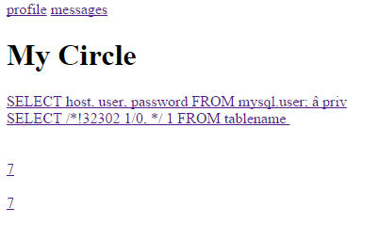

Do we need a unique url with the circle’s name or id appended? E.g. /facebook_/username/circleName

Or /facebook_/username/circleID

Need join request, approve join request, unjoin.

The circles with the same name probably have different circleId, hence display different posts results.

(If have time, can stop the same circle owner from having many circles with the same names)

**Message**

Need to delete multiple messages at a time.

Currently User can send message to oneself. Cool!

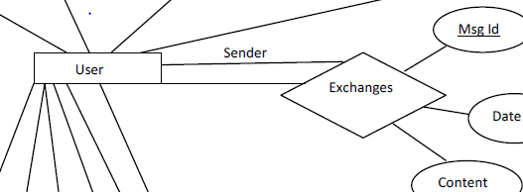

User should be able to send to many users according to this diagram-🡪 low implementation priority.

**Make a Post**

Why is user forced to log out if no content input? Strange exception handling.

If typed some space, then will get success.

Need to show multiple names of people who liked.

**Utilities**

* Allowing the manager to add and delete users
* Backing up the database files
* A comprehensive **Help** facility, including a topic-driven pull-down Help menu